WEEK1
Installation of development tools
I installed the required development tools as the following diagrams show:
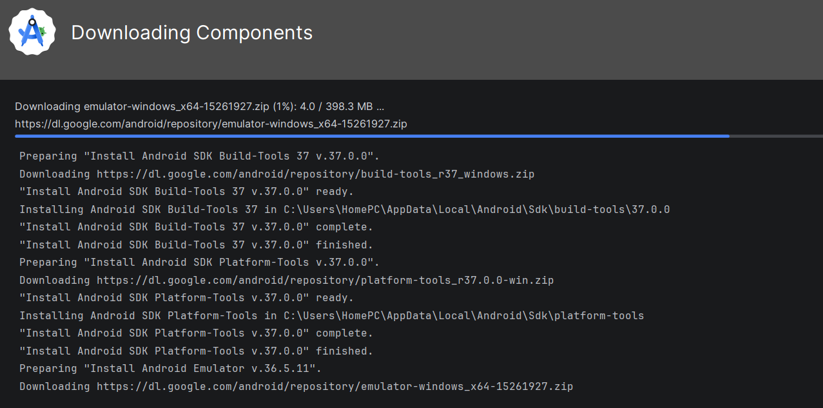
This diagram above shows the installation process of the android studio and all its tools.
After installation I went ahead to test if everything was working properly and if I could create a project with it as shown below.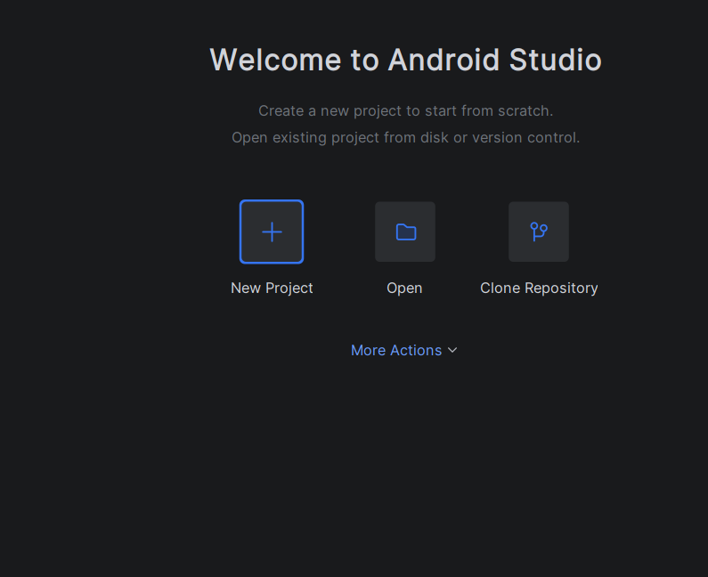
Then installed and enabled the emulator so that I could see the display after inserting a code as below.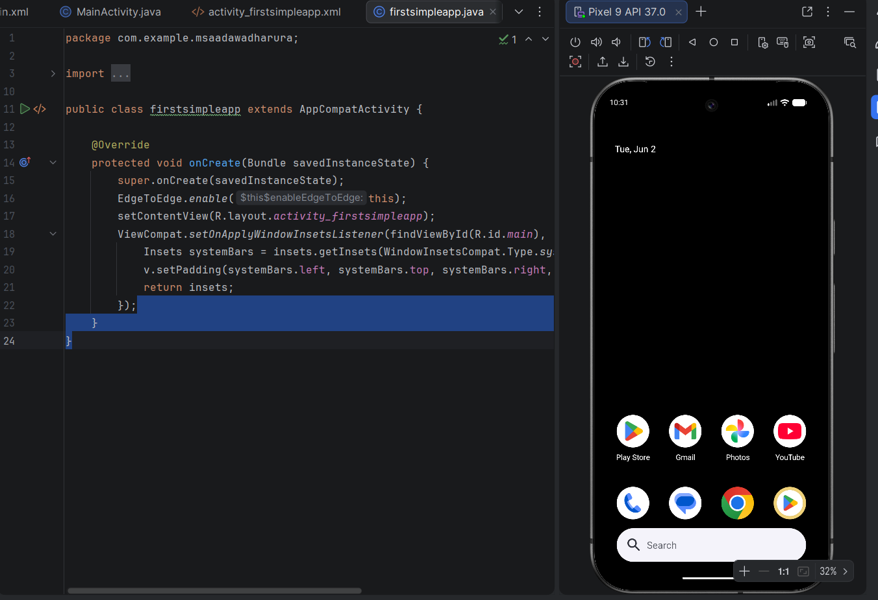
After that I headed on creating an app using java that could change title, background color and font as below.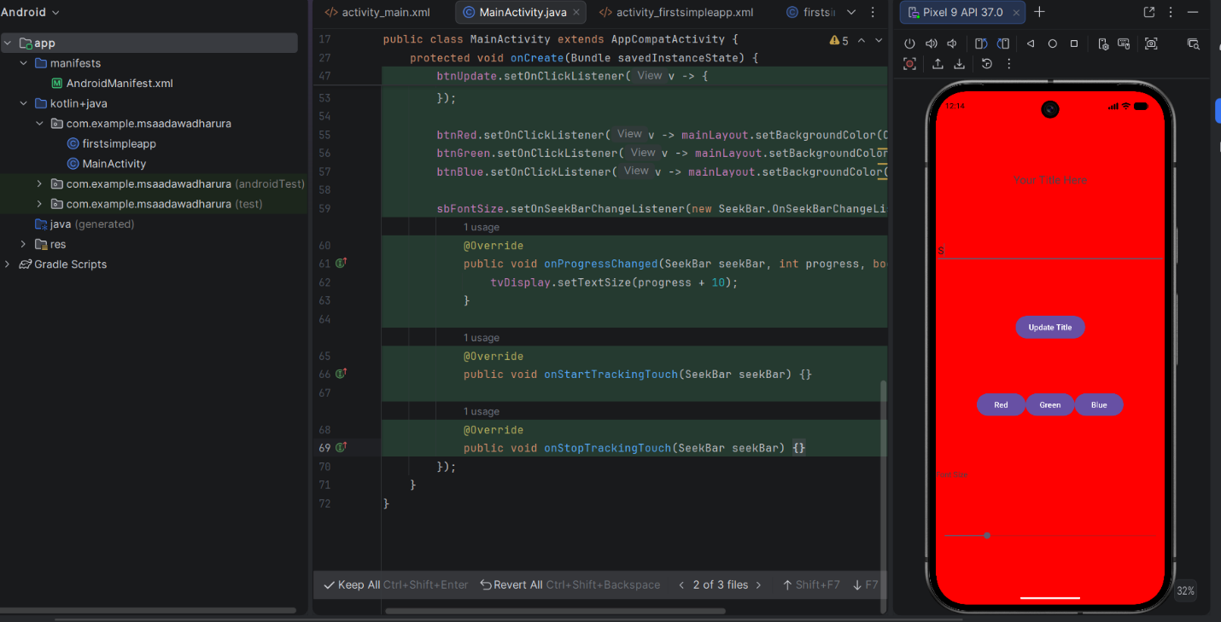
CHALLENGES
1.Code not being able to run at first.
2.Difficulty in Starting the emulator.
WEEK 2
Created a ministudentapp as the diagram below shows.
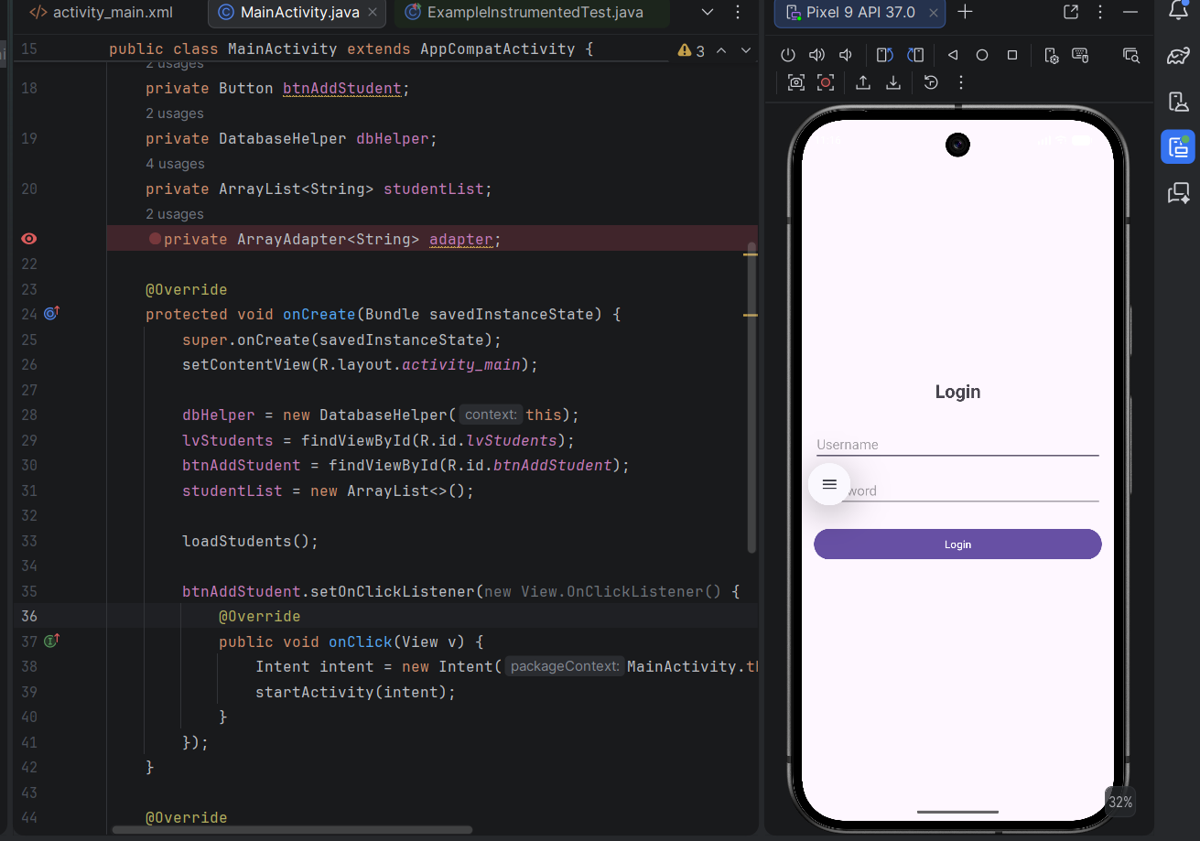
Challenges
- Emulator not running in time
- Errors in code causing emulator not to run.
- Emulator not responding instantly when numbers and letters are pressed.

WEEK 3
Here I created the Figma screens and navigation working area. I also tried to make the screens responsive and functional . The diagrams below explain everything.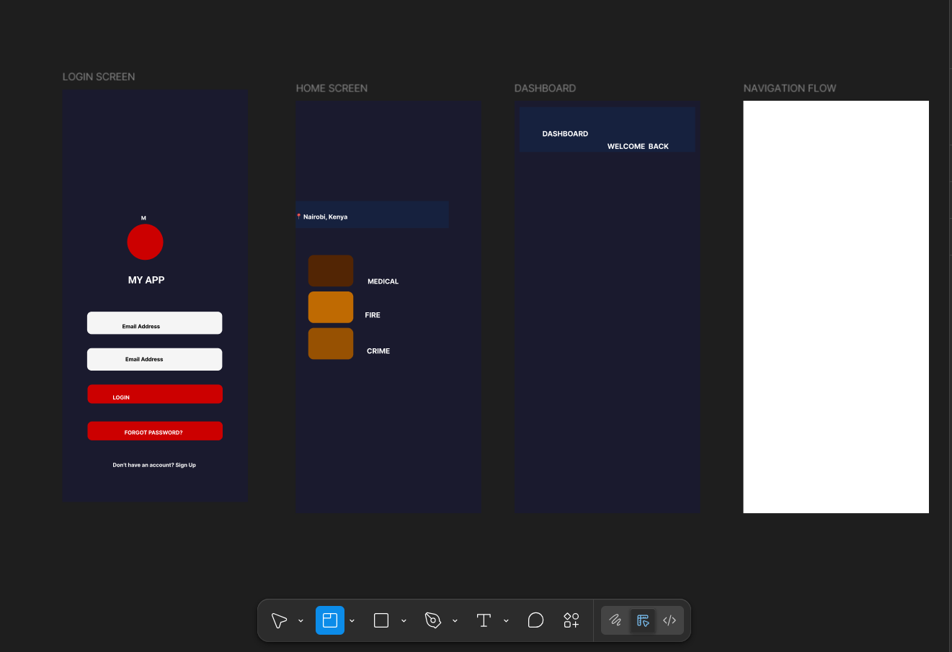
This screenshot shows the screens I designed in figma. The log in screen, Home screen , dashboard and the navigation flow.
I designed the icons and placed the icons in the screen.
I then tried to make the screens functional by adding functionality.
The diagram below shows the process.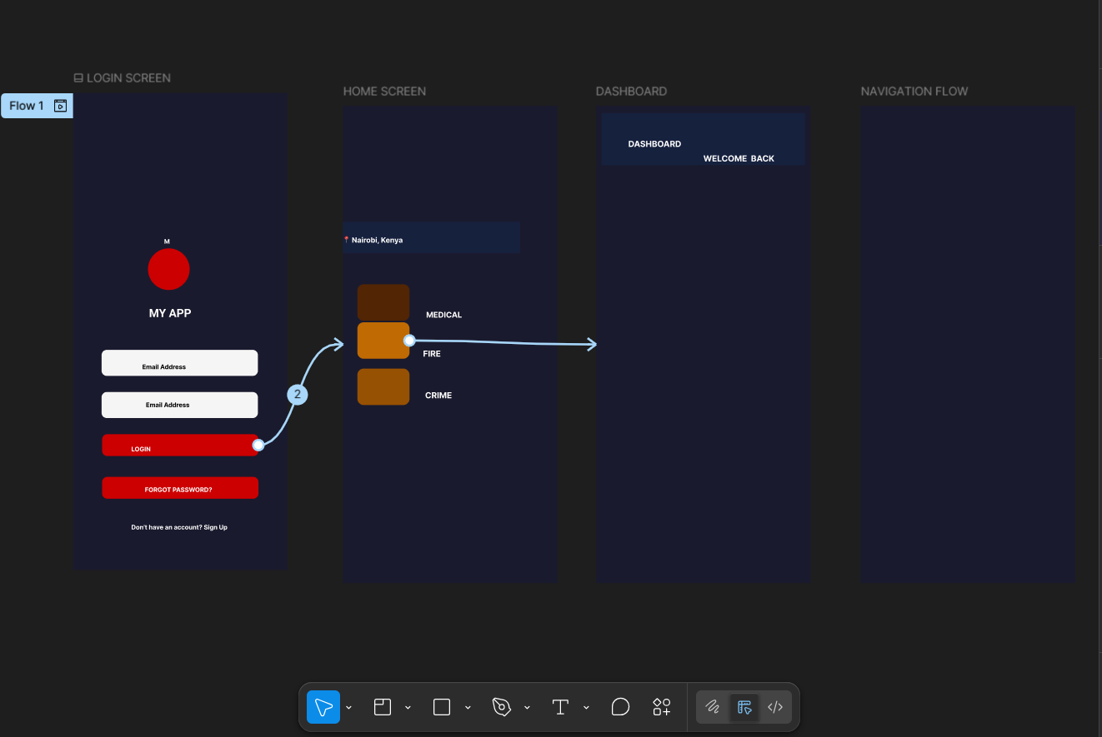
CHALLENGES
Difficulty drawing icons.
Difficulty in creating thumbnails.
Still trying to figure out.

